Project Title

Smart Vehicle Dashboard Cluster Simulator using STM32 and Qt

Project Overview
The Smart Vehicle Dashboard Cluster Simulator is an Embedded Systems and Qt-based project that simulates a modern automotive digital instrument cluster. The system uses an STM32 microcontroller to acquire real-time vehicle parameters such as speed, fuel level, and headlight status, and transmits the data through UART serial communication to a Qt-based graphical dashboard application.
The Qt application displays live vehicle information with an advanced Human Machine Interface (HMI), including speed indicators, fuel monitoring, headlight status, and safety alerts such as safe mode, medium risk mode, and overspeed warning.
This project demonstrates the integration of:
- Embedded Systems
- STM32 Microcontroller
- Qt/QML GUI Design
- Serial Communication
- Automotive Dashboard Concepts
- Real-Time Data Visualization

Objectives
- To design a real-time digital vehicle dashboard
- To interface STM32 with Qt using UART communication
- To monitor speed and fuel values using ADC sensors
- To implement headlight control using GPIO
- To develop a professional automotive-style GUI using Qt/QML
- To simulate safe driving indicators and overspeed alerts

Hardware Requirements
Component | Description
STM32 Nucleo-F446RE | Main microcontroller
Potentiometer (2) | Speed and fuel simulation
Push Button | Headlight control
LEDs | Safety status indication
USB Cable | Programming and serial communication
PC/Laptop | Running Qt Dashboard

Software Requirements
Software | Purpose
STM32CubeIDE | Embedded firmware development
Qt Creator | Qt GUI application development
Qt6 Framework | GUI and Serial communication
CMake | Build system
STM32 HAL Library | Peripheral control

System Architecture

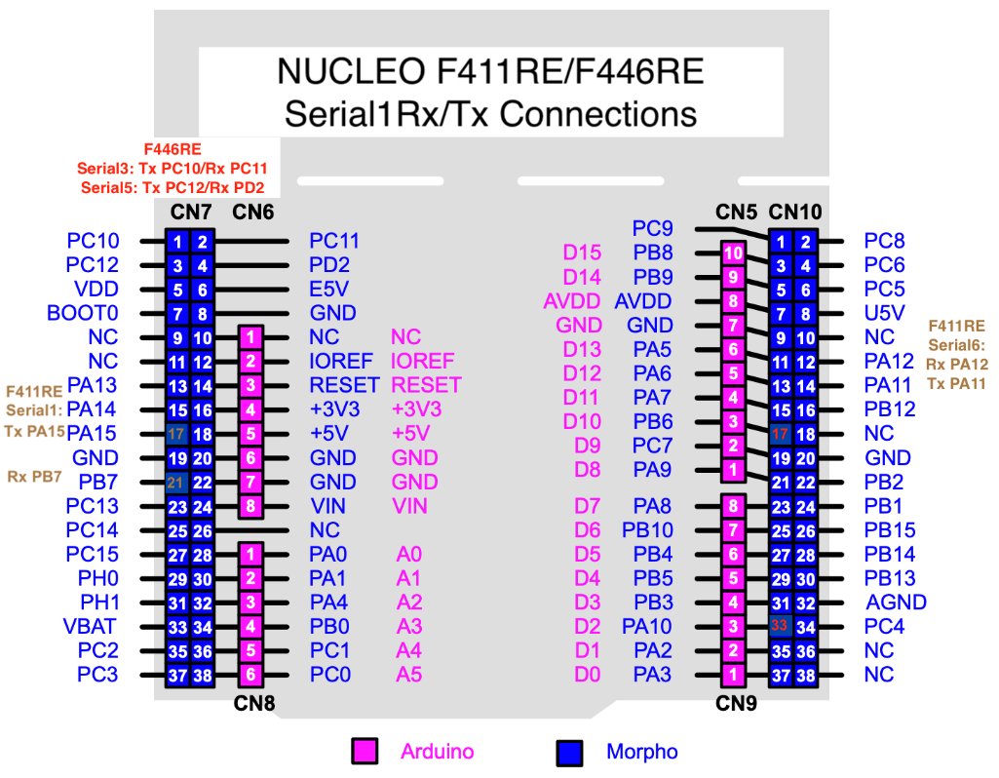

Embedded Side (STM32)
The STM32 performs:
- ADC reading from potentiometers
- Speed calculation
- Fuel percentage calculation
- Headlight button detection
- LED status indication
- UART data transmission

Qt Dashboard Side
The Qt application performs:
- UART data reception
- Real-time GUI update
- Speed visualization
- Fuel monitoring
- Safety indication
- Headlight visualization

Working Principle

Speed Monitoring
A potentiometer connected to ADC Channel 0 simulates vehicle speed.
The ADC value is converted into speed:
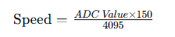
Speed ranges:
- 0–60 km/h → Safe Mode
- 61–100 km/h → Medium Safety
- 101–150 km/h → Overspeed Warning

Fuel Monitoring
Another potentiometer connected to ADC Channel 1 simulates fuel level.
Fuel percentage calculation:
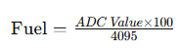

Headlight Control
A push button connected to GPIO toggles the headlight state:
- ON
- OFF
The status is transmitted to the Qt dashboard.

UART Communication
STM32 transmits vehicle data continuously through UART.
Example transmitted data:
HEADLIGHT:ON|SPEED:75 km/h|FUEL:65%
Qt receives this data and updates the dashboard in real time.

Features

Real-Time Vehicle Dashboard
- Live speed display
- Fuel percentage monitoring
- Animated progress bars

Automotive Safety Indicators
- Safe driving indicator
- Medium risk indication
- Overspeed alert system

Headlight Simulation
- ON/OFF visual indication
- Interactive GPIO control

Modern Automotive HMI
- Professional dashboard design
- Gradient background
- Digital cluster appearance

STM32 Functional Modules

STM Code:
Main.c

/* USER CODE BEGIN Header */
/**
******************************************************************************
* @file : main.c
* @brief : Main program body
******************************************************************************
* @attention
*
* Copyright (c) 2026 STMicroelectronics.
* All rights reserved.
*
* This software is licensed under terms that can be found in the LICENSE file
* in the root directory of this software component.
* If no LICENSE file comes with this software, it is provided AS-IS.
*
******************************************************************************
*/
/* USER CODE END Header */
/* Includes ------------------------------------------------------------------*/
#include "main.h"
#include <stdio.h>
#include <string.h>
#include <stdlib.h>

/* Private includes ----------------------------------------------------------*/
/* USER CODE BEGIN Includes */

/* USER CODE END Includes */

/* Private typedef -----------------------------------------------------------*/
/* USER CODE BEGIN PTD */

/* USER CODE END PTD */

/* Private define ------------------------------------------------------------*/
/* USER CODE BEGIN PD */
/* USER CODE END PD */

/* Private macro -------------------------------------------------------------*/
/* USER CODE BEGIN PM */

/* USER CODE END PM */

/* Private variables ---------------------------------------------------------*/
ADC_HandleTypeDef hadc1;

UART_HandleTypeDef huart2;

/* USER CODE BEGIN PV */
uint32_t adc_value = 0;
uint32_t speed = 0;
uint32_t fuel = 0;

uint32_t sum = 0;

char tx_buffer[100];

uint8_t headlight = 0;
uint8_t last_button_state = 1;
/* USER CODE END PV */

/* Private function prototypes -----------------------------------------------*/
void SystemClock_Config(void);
static void MX_GPIO_Init(void);
static void MX_USART2_UART_Init(void);
static void MX_ADC1_Init(void);
/* USER CODE BEGIN PFP */

/* USER CODE END PFP */

/* Private user code ---------------------------------------------------------*/
/* USER CODE BEGIN 0 */

/* USER CODE END 0 */

/**
* @brief The application entry point.
* @retval int
*/
int main(void)
{
/* USER CODE BEGIN 1 */

/* USER CODE END 1 */

/* MCU Configuration--------------------------------------------------------*/

/* Reset of all peripherals, Initializes the Flash interface and the Systick. */
HAL_Init();

/* USER CODE BEGIN Init */

/* USER CODE END Init */

/* Configure the system clock */
SystemClock_Config();

/* USER CODE BEGIN SysInit */

/* USER CODE END SysInit */

/* Initialize all configured peripherals */
MX_GPIO_Init();
MX_USART2_UART_Init();
MX_ADC1_Init();
/* USER CODE BEGIN 2 */

/* USER CODE END 2 */

/* Infinite loop */
/* USER CODE BEGIN WHILE */
uint32_t adc_value = 0;
uint32_t speed = 0;
uint32_t sum = 0;

while (1)
{
ADC_ChannelConfTypeDef sConfig = {0};

/* ================= SPEED POTENTIOMETER ================= */

sConfig.Channel = ADC_CHANNEL_0;
sConfig.Rank = 1;
sConfig.SamplingTime = ADC_SAMPLETIME_480CYCLES;

HAL_ADC_ConfigChannel(&hadc1, &sConfig);

sum = 0;

for(int i = 0; i < 20; i++)
{
HAL_ADC_Start(&hadc1);

HAL_ADC_PollForConversion(&hadc1,100);

sum += HAL_ADC_GetValue(&hadc1);

HAL_Delay(2);
}

adc_value = sum / 20;

speed = (adc_value * 150) / 4095;

/* ================= FUEL POTENTIOMETER ================= */

sConfig.Channel = ADC_CHANNEL_1;

HAL_ADC_ConfigChannel(&hadc1, &sConfig);

sum = 0;

for(int i = 0; i < 20; i++)
{
HAL_ADC_Start(&hadc1);

HAL_ADC_PollForConversion(&hadc1,100);

sum += HAL_ADC_GetValue(&hadc1);

HAL_Delay(2);
}

adc_value = sum / 20;

fuel = (adc_value * 100) / 4095;

/* ================= HEADLIGHT BUTTON ================= */

uint8_t current_button;

current_button =
HAL_GPIO_ReadPin(GPIOC, GPIO_PIN_1);

// Toggle when button pressed
if(current_button == GPIO_PIN_RESET &&
last_button_state == 1)
{
headlight = !headlight;

HAL_Delay(200);
}

last_button_state = current_button;

/* ================= SPEED LEDs ================= */
/* ACTIVE LOW TRAFFIC MODULE */
/* ================= SPEED LEDs ================= */

// FIRST turn OFF all LEDs

HAL_GPIO_WritePin(GPIOB, GPIO_PIN_0, GPIO_PIN_RESET);
HAL_GPIO_WritePin(GPIOB, GPIO_PIN_1, GPIO_PIN_RESET);
HAL_GPIO_WritePin(GPIOB, GPIO_PIN_10, GPIO_PIN_RESET);

// 0 - 60 --> GREEN

if(speed >= 0 && speed <= 60)
{
HAL_GPIO_WritePin(GPIOB,
GPIO_PIN_0,
GPIO_PIN_SET);
}

// 51 - 100 --> YELLOW

else if(speed > 60 && speed <= 100)
{
HAL_GPIO_WritePin(GPIOB,
GPIO_PIN_1,
GPIO_PIN_SET);
}

// 101 - 150 --> RED

else
{
HAL_GPIO_WritePin(GPIOB,
GPIO_PIN_10,
GPIO_PIN_SET);
}

/* ================= HEADLIGHT STATUS ================= */

char headlight_status[10];

if(headlight)
{
strcpy(headlight_status,"ON ");
}
else
{
strcpy(headlight_status,"OFF");
}

/* ================= UART OUTPUT ================= */

sprintf(tx_buffer,
"HEADLIGHT:%s|SPEED:%d km/h|FUEL:%d%%\r\n",
headlight_status,
speed,
fuel);

HAL_UART_Transmit(&huart2,
(uint8_t*)tx_buffer,
strlen(tx_buffer),
100);

HAL_Delay(500);
}

/* USER CODE END 3 */
}

/**
* @brief System Clock Configuration
* @retval None
*/
void SystemClock_Config(void)
{
RCC_OscInitTypeDef RCC_OscInitStruct = {0};
RCC_ClkInitTypeDef RCC_ClkInitStruct = {0};

/** Configure the main internal regulator output voltage
*/
__HAL_RCC_PWR_CLK_ENABLE();
__HAL_PWR_VOLTAGESCALING_CONFIG(PWR_REGULATOR_VOLTAGE_SCALE3);
/** Initializes the RCC Oscillators according to the specified parameters
* in the RCC_OscInitTypeDef structure.
*/
RCC_OscInitStruct.OscillatorType = RCC_OSCILLATORTYPE_HSI;
RCC_OscInitStruct.HSIState = RCC_HSI_ON;
RCC_OscInitStruct.HSICalibrationValue = RCC_HSICALIBRATION_DEFAULT;
RCC_OscInitStruct.PLL.PLLState = RCC_PLL_ON;
RCC_OscInitStruct.PLL.PLLSource = RCC_PLLSOURCE_HSI;
RCC_OscInitStruct.PLL.PLLM = 16;
RCC_OscInitStruct.PLL.PLLN = 336;
RCC_OscInitStruct.PLL.PLLP = RCC_PLLP_DIV4;
RCC_OscInitStruct.PLL.PLLQ = 2;
RCC_OscInitStruct.PLL.PLLR = 2;
if (HAL_RCC_OscConfig(&RCC_OscInitStruct) != HAL_OK)
{
Error_Handler();
}
/** Initializes the CPU, AHB and APB buses clocks
*/
RCC_ClkInitStruct.ClockType = RCC_CLOCKTYPE_HCLK|RCC_CLOCKTYPE_SYSCLK
|RCC_CLOCKTYPE_PCLK1|RCC_CLOCKTYPE_PCLK2;
RCC_ClkInitStruct.SYSCLKSource = RCC_SYSCLKSOURCE_PLLCLK;
RCC_ClkInitStruct.AHBCLKDivider = RCC_SYSCLK_DIV1;
RCC_ClkInitStruct.APB1CLKDivider = RCC_HCLK_DIV2;
RCC_ClkInitStruct.APB2CLKDivider = RCC_HCLK_DIV1;

if (HAL_RCC_ClockConfig(&RCC_ClkInitStruct, FLASH_LATENCY_2) != HAL_OK)
{
Error_Handler();
}
}

/**
* @brief ADC1 Initialization Function
* @param None
* @retval None
*/
static void MX_ADC1_Init(void)
{

/* USER CODE BEGIN ADC1_Init 0 */

/* USER CODE END ADC1_Init 0 */

ADC_ChannelConfTypeDef sConfig = {0};

/* USER CODE BEGIN ADC1_Init 1 */

/* USER CODE END ADC1_Init 1 */
/** Configure the global features of the ADC (Clock, Resolution, Data Alignment and number of conversion)
*/
hadc1.Instance = ADC1;
hadc1.Init.ClockPrescaler = ADC_CLOCK_SYNC_PCLK_DIV4;
hadc1.Init.Resolution = ADC_RESOLUTION_12B;
hadc1.Init.ScanConvMode = DISABLE;
hadc1.Init.ContinuousConvMode = DISABLE;
hadc1.Init.DiscontinuousConvMode = DISABLE;
hadc1.Init.ExternalTrigConvEdge = ADC_EXTERNALTRIGCONVEDGE_NONE;
hadc1.Init.ExternalTrigConv = ADC_SOFTWARE_START;
hadc1.Init.DataAlign = ADC_DATAALIGN_RIGHT;
hadc1.Init.NbrOfConversion = 1;
hadc1.Init.DMAContinuousRequests = DISABLE;
hadc1.Init.EOCSelection = ADC_EOC_SINGLE_CONV;
if (HAL_ADC_Init(&hadc1) != HAL_OK)
{
Error_Handler();
}
/** Configure for the selected ADC regular channel its corresponding rank in the sequencer and its sample time.
*/
sConfig.Channel = ADC_CHANNEL_0;
sConfig.Rank = 1;
sConfig.SamplingTime = ADC_SAMPLETIME_3CYCLES;
if (HAL_ADC_ConfigChannel(&hadc1, &sConfig) != HAL_OK)
{
Error_Handler();
}
/* USER CODE BEGIN ADC1_Init 2 */

/* USER CODE END ADC1_Init 2 */

}

/**
* @brief USART2 Initialization Function
* @param None
* @retval None
*/
static void MX_USART2_UART_Init(void)
{

/* USER CODE BEGIN USART2_Init 0 */

/* USER CODE END USART2_Init 0 */

/* USER CODE BEGIN USART2_Init 1 */

/* USER CODE END USART2_Init 1 */
huart2.Instance = USART2;
huart2.Init.BaudRate = 115200;
huart2.Init.WordLength = UART_WORDLENGTH_8B;
huart2.Init.StopBits = UART_STOPBITS_1;
huart2.Init.Parity = UART_PARITY_NONE;
huart2.Init.Mode = UART_MODE_TX_RX;
huart2.Init.HwFlowCtl = UART_HWCONTROL_NONE;
huart2.Init.OverSampling = UART_OVERSAMPLING_16;
if (HAL_UART_Init(&huart2) != HAL_OK)
{
Error_Handler();
}
/* USER CODE BEGIN USART2_Init 2 */

/* USER CODE END USART2_Init 2 */

}

/**
* @brief GPIO Initialization Function
* @param None
* @retval None
*/
static void MX_GPIO_Init(void)
{
GPIO_InitTypeDef GPIO_InitStruct = {0};

/* GPIO Ports Clock Enable */
__HAL_RCC_GPIOC_CLK_ENABLE();
__HAL_RCC_GPIOH_CLK_ENABLE();
__HAL_RCC_GPIOA_CLK_ENABLE();
__HAL_RCC_GPIOB_CLK_ENABLE();

/*Configure GPIO pin Output Level */
HAL_GPIO_WritePin(LD2_GPIO_Port, LD2_Pin, GPIO_PIN_RESET);

/*Configure GPIO pin Output Level */
HAL_GPIO_WritePin(GPIOB,
GPIO_PIN_0|GPIO_PIN_1|GPIO_PIN_2|GPIO_PIN_10,GPIO_PIN_SET);

/*Configure GPIO pin : B1_Pin */
GPIO_InitStruct.Pin = B1_Pin;
GPIO_InitStruct.Mode = GPIO_MODE_IT_FALLING;
GPIO_InitStruct.Pull = GPIO_NOPULL;
HAL_GPIO_Init(B1_GPIO_Port, &GPIO_InitStruct);

/*Configure GPIO pins : PC1 PC2 PC3 */
GPIO_InitStruct.Pin = GPIO_PIN_1|GPIO_PIN_2|GPIO_PIN_3;
GPIO_InitStruct.Mode = GPIO_MODE_INPUT;
GPIO_InitStruct.Pull = GPIO_PULLUP;
HAL_GPIO_Init(GPIOC, &GPIO_InitStruct);

/*Configure GPIO pin : LD2_Pin */
GPIO_InitStruct.Pin = LD2_Pin;
GPIO_InitStruct.Mode = GPIO_MODE_OUTPUT_PP;
GPIO_InitStruct.Pull = GPIO_NOPULL;
GPIO_InitStruct.Speed = GPIO_SPEED_FREQ_LOW;
HAL_GPIO_Init(LD2_GPIO_Port, &GPIO_InitStruct);

/*Configure GPIO pins : PB0 PB1 PB2 PB10 */
GPIO_InitStruct.Pin = GPIO_PIN_0|GPIO_PIN_1|GPIO_PIN_2|GPIO_PIN_10;
GPIO_InitStruct.Mode = GPIO_MODE_OUTPUT_PP;
GPIO_InitStruct.Pull = GPIO_NOPULL;
GPIO_InitStruct.Speed = GPIO_SPEED_FREQ_LOW;
HAL_GPIO_Init(GPIOB, &GPIO_InitStruct);

}

/* USER CODE BEGIN 4 */

/* USER CODE END 4 */

/**
* @brief This function is executed in case of error occurrence.
* @retval None
*/
void Error_Handler(void)
{
/* USER CODE BEGIN Error_Handler_Debug */
/* User can add his own implementation to report the HAL error return state */
__disable_irq();
while (1)
{
}
/* USER CODE END Error_Handler_Debug */
}

#ifdef USE_FULL_ASSERT
/**
* @brief Reports the name of the source file and the source line number
* where the assert_param error has occurred.
* @param file: pointer to the source file name
* @param line: assert_param error line source number
* @retval None
*/
void assert_failed(uint8_t *file, uint32_t line)
{
/* USER CODE BEGIN 6 */
/* User can add his own implementation to report the file name and line number,
ex: printf("Wrong parameters value: file %s on line %d\r\n", file, line) */
/* USER CODE END 6 */
}
#endif /* USE_FULL_ASSERT */

ADC Module
Used for:
- Speed sensor simulation
- Fuel sensor simulation

GPIO Module
Used for:
- Headlight switch input
- LED output indication

UART Module
Used for:
- Serial communication with Qt dashboard

Pin diagram
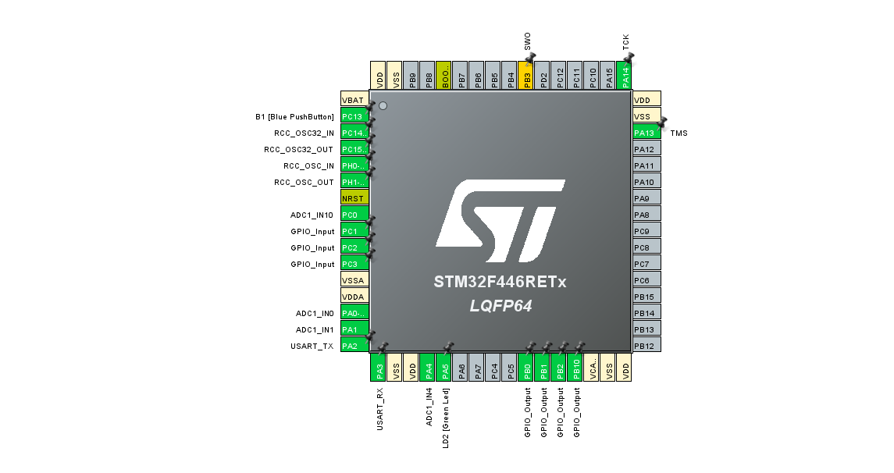

Qt Dashboard Modules

Qt Code:
Cmake
cmake_minimum_required(VERSION 3.16)

project(final_vehicle_dashboard LANGUAGES CXX)

set(CMAKE_CXX_STANDARD 17)

find_package(Qt6 REQUIRED COMPONENTS Quick SerialPort)

qt_standard_project_setup()

qt_add_executable(appfinal_vehicle_dashboard
main.cpp
serialmanager.cpp
)

qt_add_qml_module(appfinal_vehicle_dashboard
URI final_vehicle_dashboard
VERSION 1.0
QML_FILES
Main.qml
)

target_sources(appfinal_vehicle_dashboard PRIVATE
serialmanager.h
)

target_link_libraries(appfinal_vehicle_dashboard PRIVATE
Qt6::Quick
Qt6::SerialPort
)

Main.cpp

#include <QGuiApplication>
#include <QQmlApplicationEngine>
#include <QQmlContext>

#include "serialmanager.h"

int main(int argc, char *argv[])
{
QGuiApplication app(argc, argv);

QQmlApplicationEngine engine;

SerialManager backend;

engine.rootContext()->setContextProperty(
"backend",
&backend);

engine.loadFromModule(
"final_vehicle_dashboard",
"Main");

if(engine.rootObjects().isEmpty())
return -1;

return app.exec();
}

Main.qml

import QtQuick
import QtQuick.Controls
import QtQuick.Layouts

ApplicationWindow {

visible: true
width: 1200
height: 700
title: "Professional Vehicle Dashboard"

Rectangle {
anchors.fill: parent

gradient: Gradient {
GradientStop { position: 0.0; color: "#0f172a" }
GradientStop { position: 1.0; color: "#1e293b" }
}

Column {

anchors.centerIn: parent
spacing: 40

Text {
text: "SMART VEHICLE DASHBOARD"
color: "cyan"
font.pixelSize: 42
font.bold: true
anchors.horizontalCenter: parent.horizontalCenter
}

Row {

spacing: 40
anchors.horizontalCenter: parent.horizontalCenter

Rectangle {
width: 320
height: 220
radius: 20
color: "#1e3a8a"
border.color: "#38bdf8"
border.width: 3

Column {
anchors.centerIn: parent
spacing: 20

Text {
text: "SPEED"
color: "white"
font.pixelSize: 30
font.bold: true
}

Text {
text: backend.speed + " km/h"
color: "cyan"
font.pixelSize: 48
font.bold: true
}

ProgressBar {
width: 220
value: backend.speed / 150
}
}
}

Rectangle {
width: 320
height: 220
radius: 20
color: "#3f1d0d"
border.color: "#f59e0b"
border.width: 3

Column {
anchors.centerIn: parent
spacing: 20

Text {
text: "FUEL"
color: "white"
font.pixelSize: 30
font.bold: true
}

Text {
text: backend.fuel + "%"
color: "orange"
font.pixelSize: 48
font.bold: true
}

ProgressBar {
width: 220
value: backend.fuel / 100
}
}
}
}

Rectangle {

width: 700
height: 220
radius: 20

color: "#1e293b"

border.color: "#34d399"
border.width: 3

anchors.horizontalCenter: parent.horizontalCenter

Column {

anchors.centerIn: parent
spacing: 25

Text {
text: "VEHICLE STATUS"
color: "white"
font.pixelSize: 34
font.bold: true
anchors.horizontalCenter: parent.horizontalCenter
}

Row {

spacing: 60
anchors.horizontalCenter: parent.horizontalCenter

Column {
spacing: 10

Rectangle {
width: 55
height: 55
radius: 30

color: backend.headlight === "ON" ? "white" : "gray"

border.color: "white"
border.width: 2
}

Text {
text: "HEADLIGHT"
color: "white"
}
}

Column {
spacing: 10

Rectangle {
width: 55
height: 55
radius: 30

color: backend.speed < 60 ? "green" : "gray"

border.color: "white"
border.width: 2
}

Text {
text: "SAFE"
color: "white"
}
}

Column {
spacing: 10

Rectangle {
width: 55
height: 55
radius: 30

color: backend.speed >= 60
&& backend.speed <= 100
? "yellow" : "gray"

border.color: "white"
border.width: 2
}

Text {
text: "MEDIUM"
color: "white"
}
}

Column {
spacing: 10

Rectangle {
width: 55
height: 55
radius: 30

color: backend.speed > 100
? "red" : "gray"

border.color: "white"
border.width: 2
}

Text {
text: "OVER SPEED"
color: "white"
}
}
}
}
}
}
}
}
Serialmanager.cpp
#include "serialmanager.h"

SerialManager::SerialManager(QObject *parent)
: QObject(parent)
{
serial.setPortName("COM13");
serial.setBaudRate(QSerialPort::Baud115200);

if(serial.open(QIODevice::ReadOnly))
{
connect(&serial,
&QSerialPort::readyRead,
this,
&SerialManager::readSerialData);
}
}

int SerialManager::speed() const
{
return m_speed;
}

int SerialManager::fuel() const
{
return m_fuel;
}

QString SerialManager::headlight() const
{
return m_headlight;
}

void SerialManager::readSerialData()
{
while(serial.canReadLine())
{
QByteArray data = serial.readLine();

QString str(data);

str = str.trimmed();

QStringList parts = str.split("|");

for(const QString &part : parts)
{
if(part.contains("SPEED"))
{
QStringList s = part.split(":");

if(s.size() >= 2)
{
QString value = s[1];

value.replace("km/h", "");

m_speed = value.trimmed().toInt();
}
}

else if(part.contains("FUEL"))
{
QStringList f = part.split(":");

if(f.size() >= 2)
{
QString value = f[1];

value.replace("%", "");

m_fuel = value.trimmed().toInt();
}
}

else if(part.contains("HEADLIGHT"))
{
QStringList h = part.split(":");

if(h.size() >= 2)
{
m_headlight = h[1].trimmed();
}
}
}

emit dataChanged();
}
}

Serialmanager,h

#ifndef SERIALMANAGER_H
#define SERIALMANAGER_H

#include <QObject>
#include <QSerialPort>

class SerialManager : public QObject
{
Q_OBJECT

Q_PROPERTY(int speed READ speed NOTIFY dataChanged)
Q_PROPERTY(int fuel READ fuel NOTIFY dataChanged)
Q_PROPERTY(QString headlight READ headlight NOTIFY dataChanged)

public:
explicit SerialManager(QObject *parent = nullptr);

int speed() const;
int fuel() const;
QString headlight() const;

signals:
void dataChanged();

private slots:
void readSerialData();

private:
QSerialPort serial;

int m_speed = 0;
int m_fuel = 0;

QString m_headlight = "OFF";
};

#endif

SerialManager Class
Responsible for:
- Reading UART data
- Parsing vehicle information
- Updating GUI properties

QML User Interface
Provides:
- Modern dashboard design
- Real-time updates
- Vehicle indicators
- Progress bars

Connection:
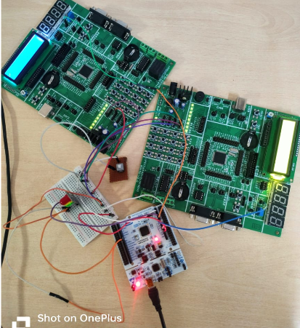

Pin Configuration
STM32 Pin | Function
PA0 | Speed ADC Input
PA1 | Fuel ADC Input
PC1 | Headlight Button
PB0 | Safe Mode LED
PB1 | Medium Mode LED
PB10 | Overspeed LED
USART2 TX/RX | Serial Communication

Flowchart

STM32 Flow
- Initialize peripherals
- Read speed ADC
- Read fuel ADC
- Read headlight button
- Update LED indicators
- Send UART data
- Repeat continuously

Qt Flow
- Open serial port
- Receive UART data
- Parse values
- Update GUI
- Refresh dashboard

Advantages
- Real-time monitoring system
- Beginner-friendly automotive project
- Professional Qt GUI design
- Embedded + GUI integration
- Scalable for advanced automotive systems
- Useful for learning automotive HMI concepts

Applications
- Automotive digital instrument clusters
- Smart vehicle monitoring systems
- Driver assistance systems
- Automotive HMI research
- Embedded systems education
- Real-time telemetry systems

Future Enhancements
- GPS integration
- CAN Bus communication
- Touchscreen support
- AI-based driver monitoring
- Android Automotive integration
- Voice assistant support
- Temperature monitoring
- Tire pressure monitoring system

Expected Output
Qt output
Safe mode
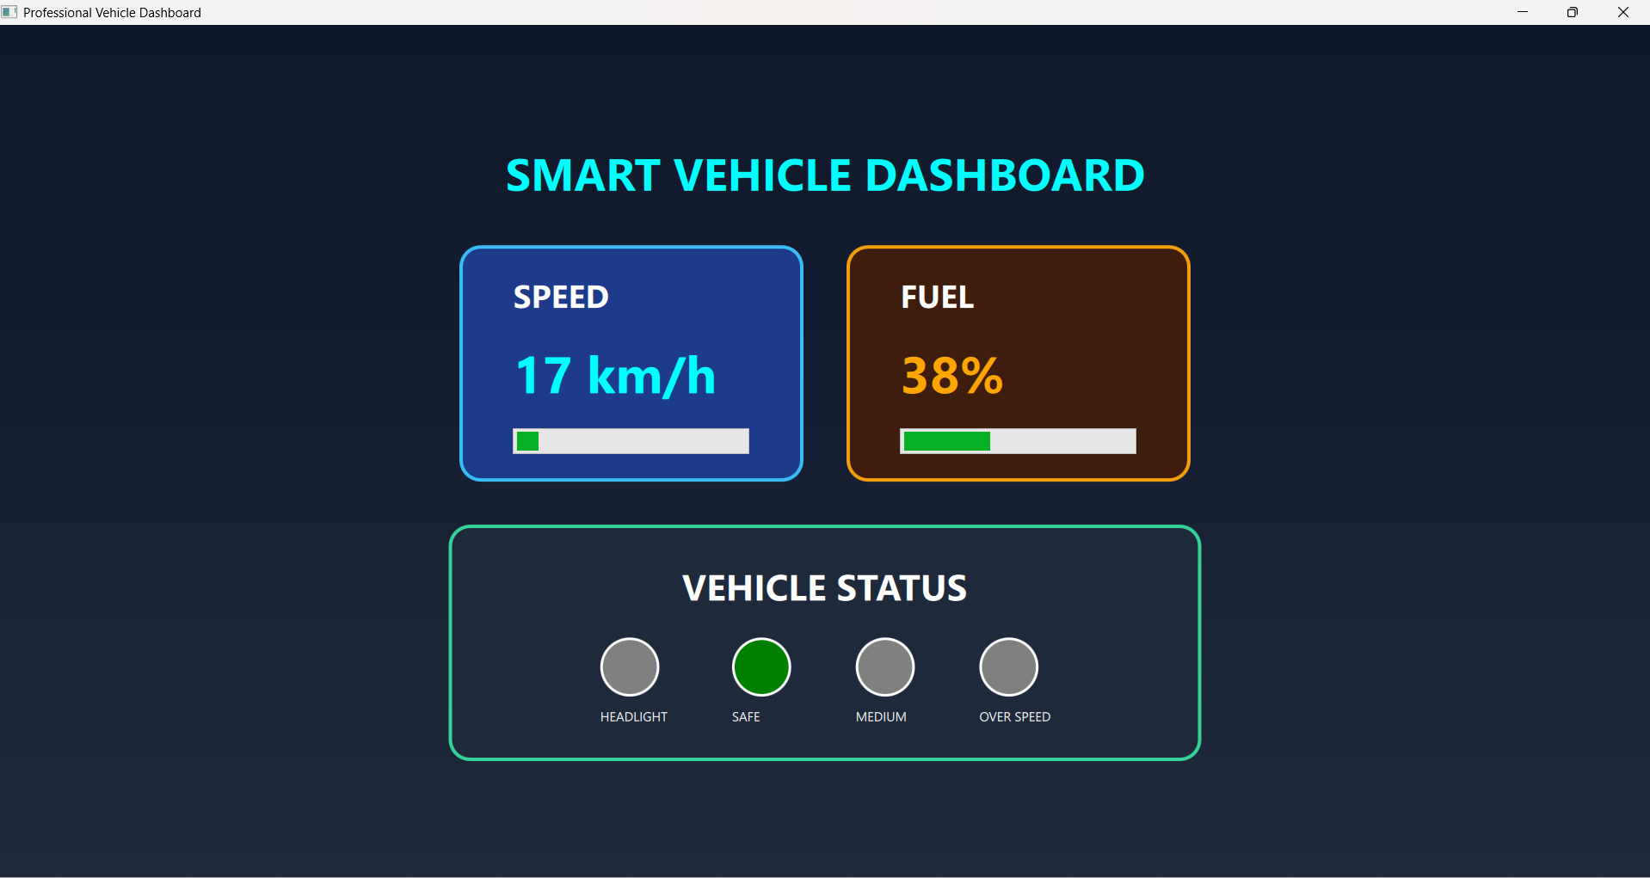
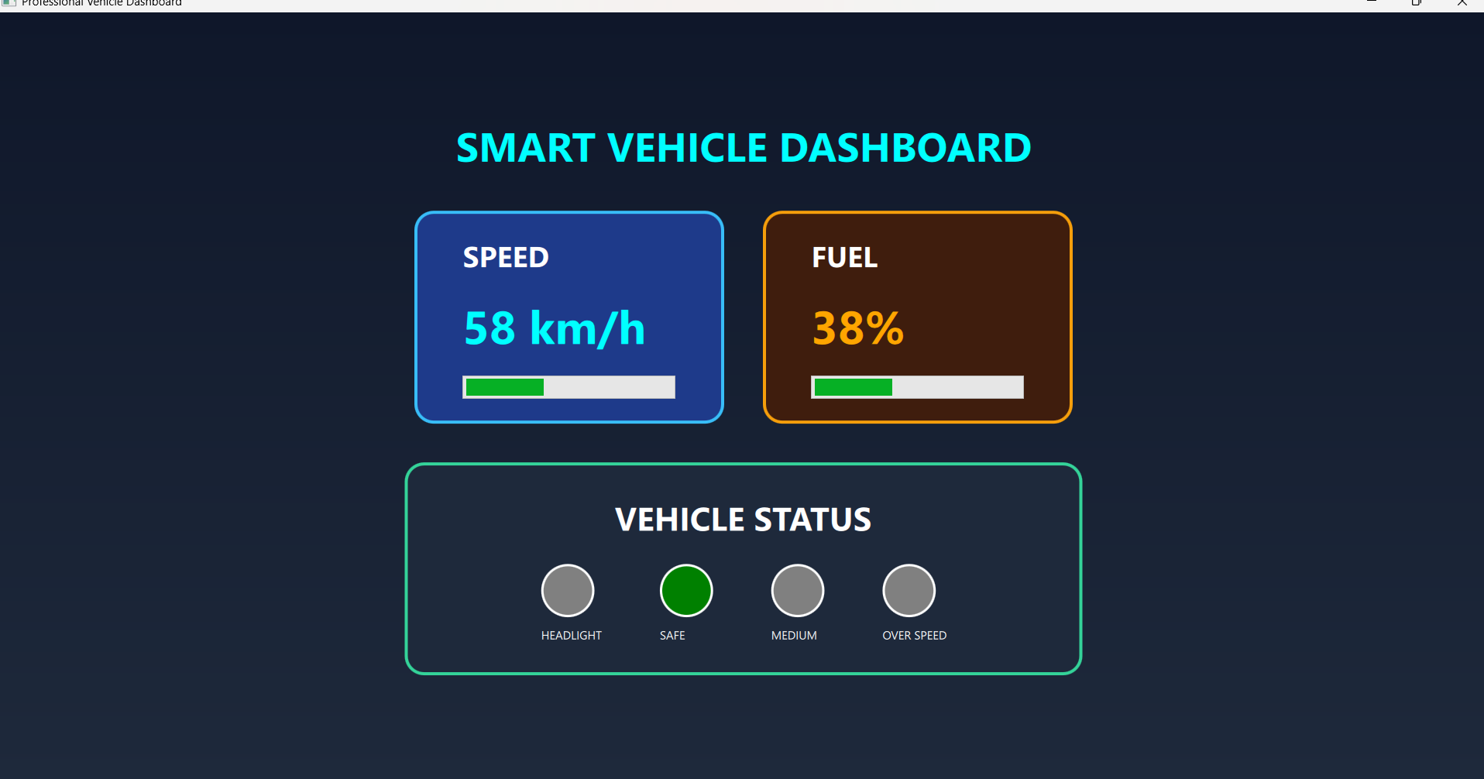

Medium safe
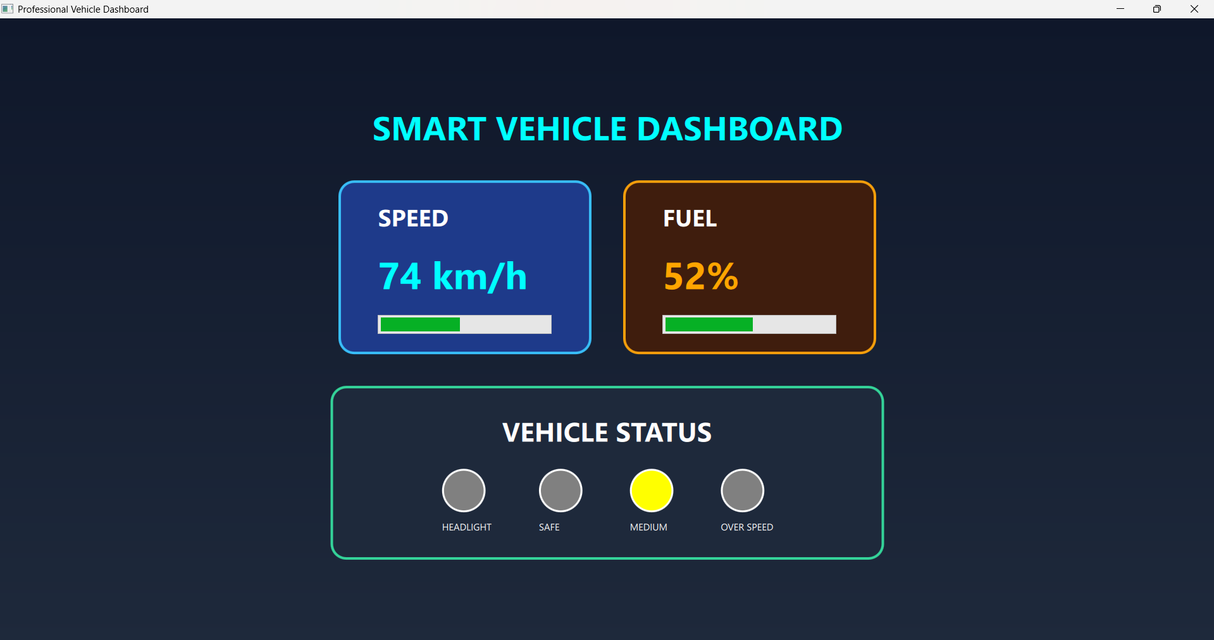
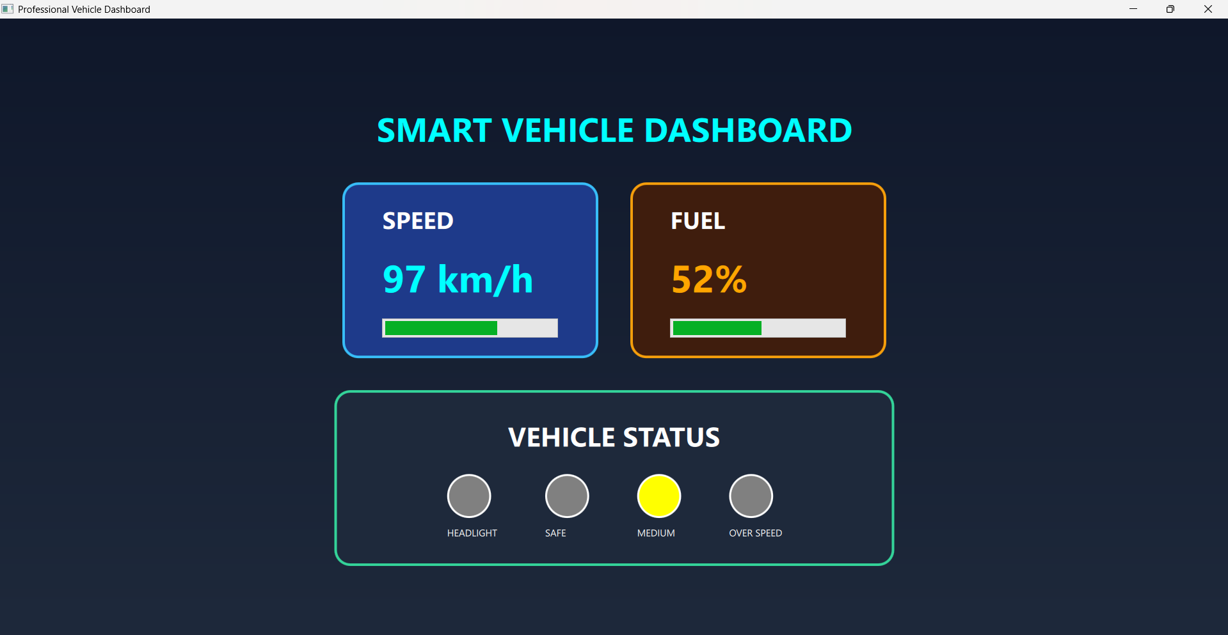

Over speed 101-150km/h
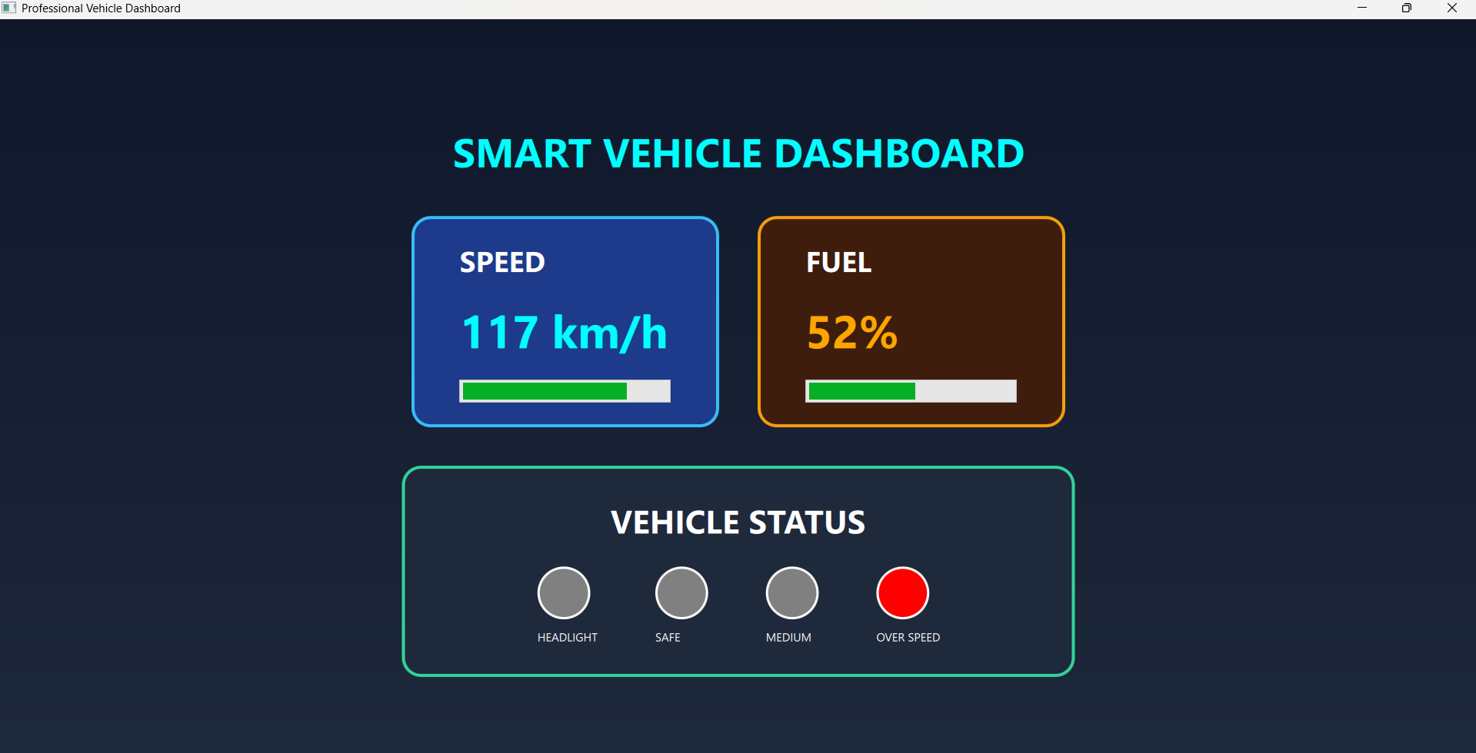

Fuel
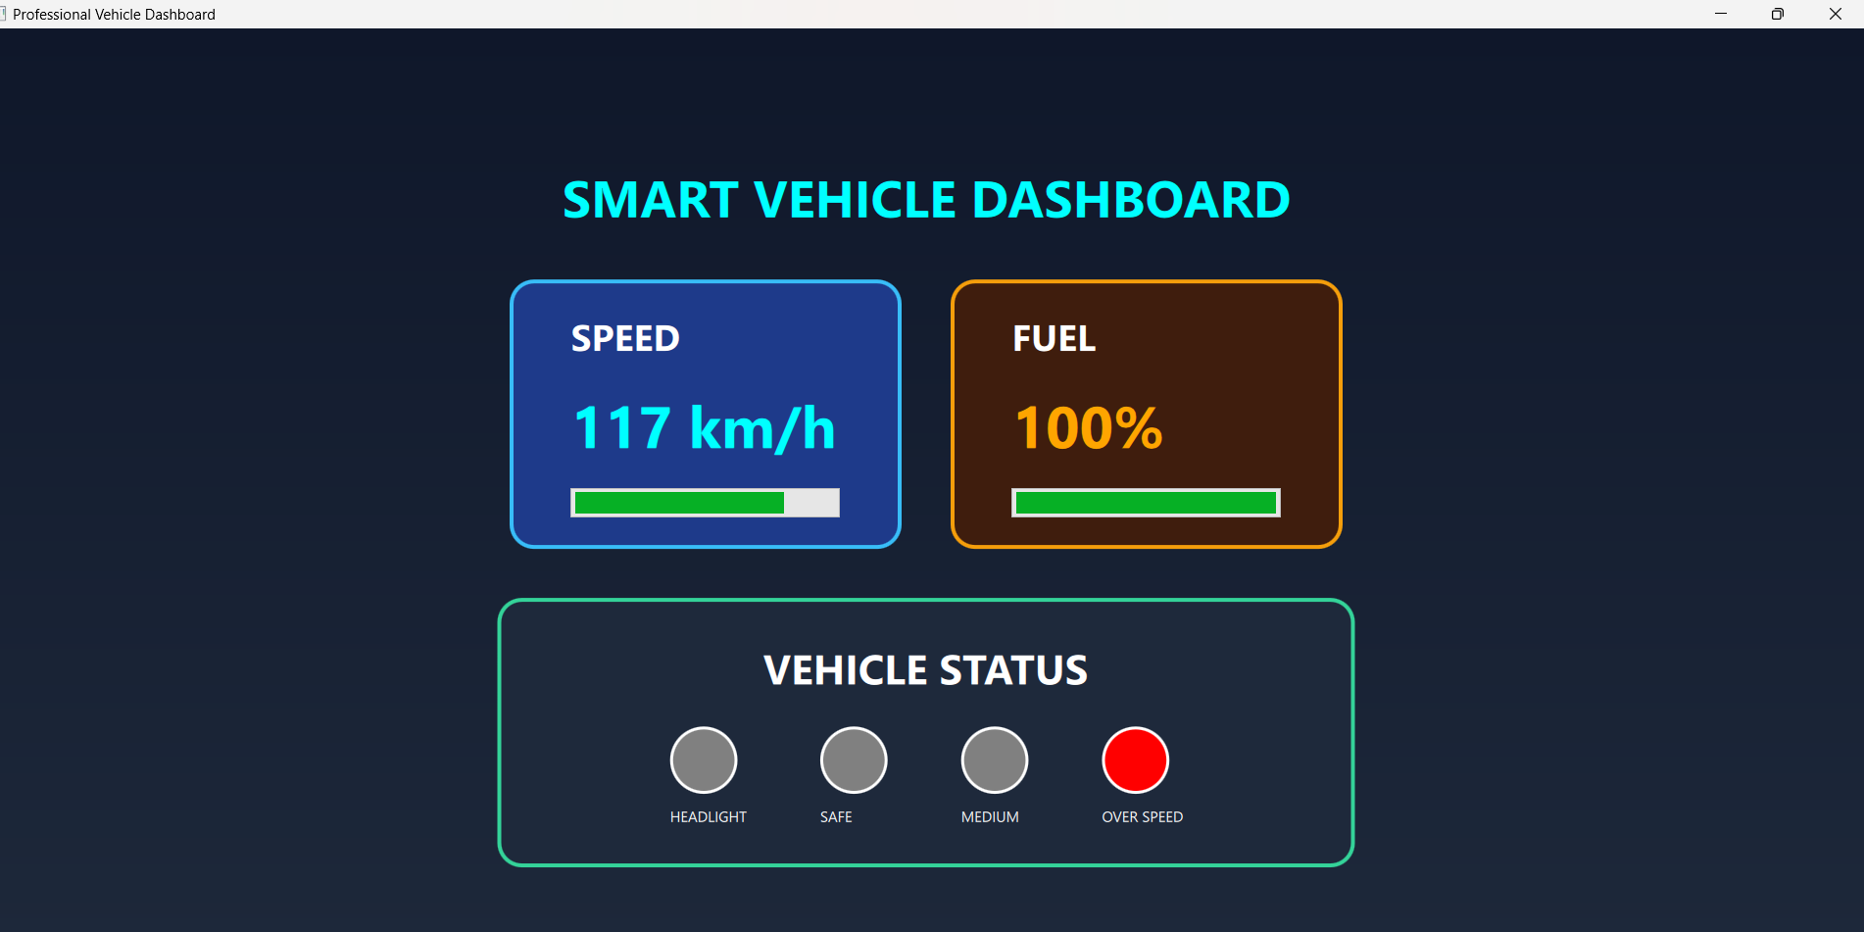
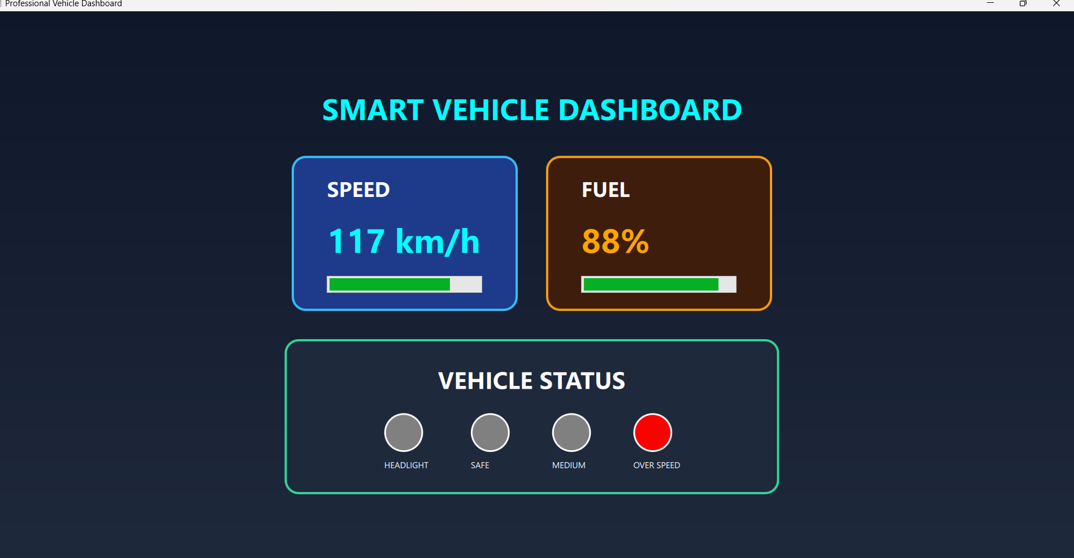
Headlight
Mode: OFF
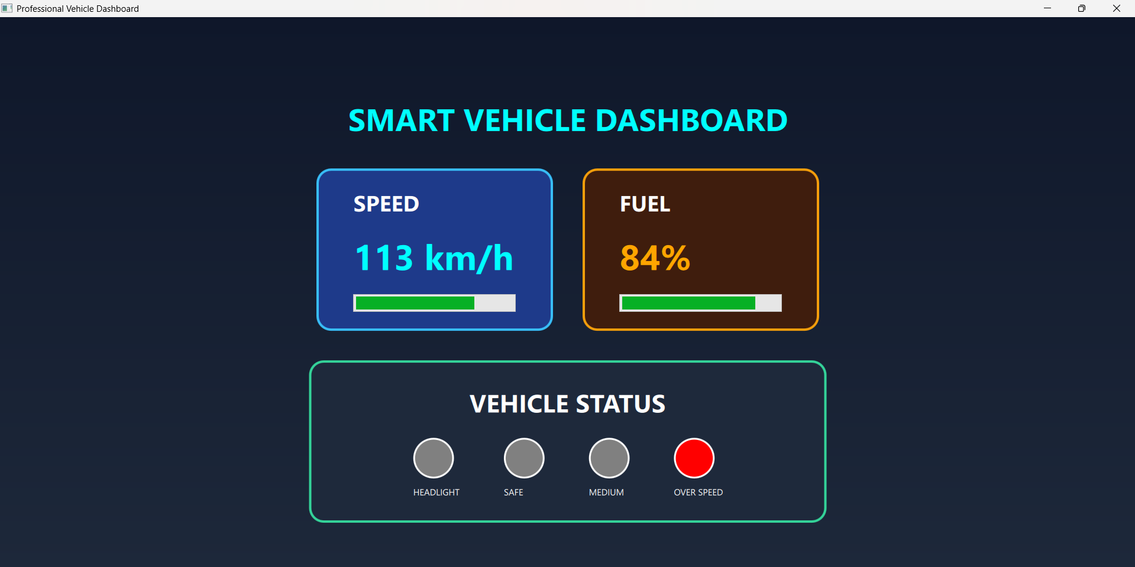
Mode: ON
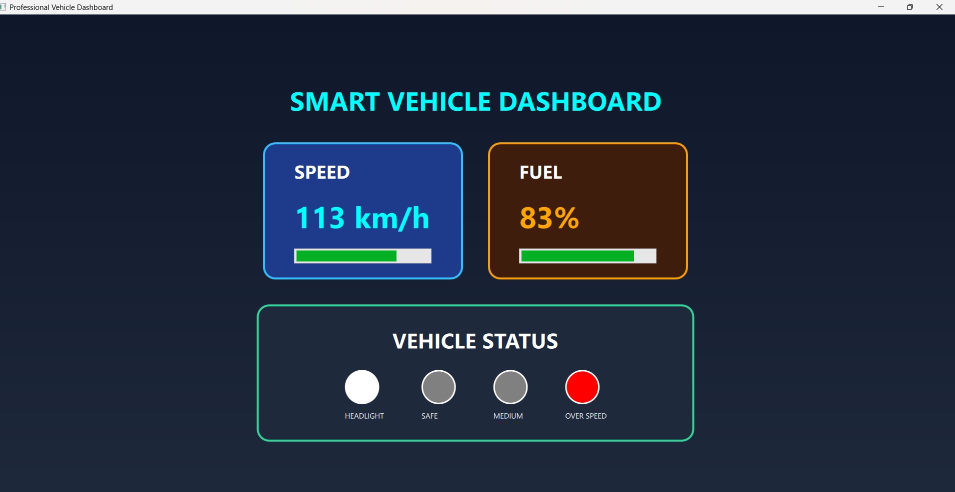

Dashboard Displays
- Vehicle speed
- Fuel percentage
- Headlight status
- Safety indicators

LED Indications
- Green LED → Safe speed
- Yellow LED → Medium speed
- Red LED → Overspeed condition

Conclusion
The Smart Vehicle Dashboard Cluster Simulator demonstrates the successful integration of STM32 embedded systems with Qt-based graphical user interfaces. The project provides a real-time automotive dashboard simulation with live sensor monitoring, serial communication, and intelligent safety visualization.
This project is highly suitable for:
- Embedded systems learning
- Automotive HMI development
- Qt and QML practice
- Real-time GUI applications
- Automotive electronics projects

